|  |  |  |
| --- | --- | --- |
|  | **ST. FRANCIS INSTITUTE OF TECHNOLOGY**  **Mount Poinsur, Borivali (West), Mumbai-400103**  **Department of Information Technology**  **Information Technology Students’ Association (ITSA)** |  |

***ITSA’ ESCROW!!***

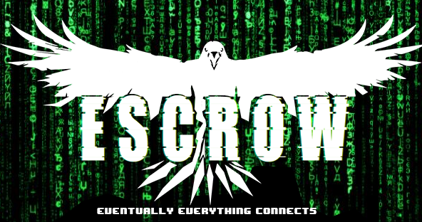

**Date: 27th July, 2020**

SFIT ITSA once again continuing its series of new concepts and challenges introduced it’s first event for the academic year 2020-21 viz. ESCROW. ESCROW was basically a virtual treasure hunt based on the skills of cryptography, cipher, coding and logical thinking.

ITSA’ ESCROW was a three round event divided in two days basically the 16th  and 17th  of July 2020. Considering the current lockdown we made use of Instagram, Twitter, YouTube, Google Maps and [notepad.pw](http://notepad.pw/) for hiding our clues. The clues were spread over these domains.  We had 3 rounds spread over 2 days. The first round was based on Mathematical and logical questions, second was based on technical and coding. Round 3 was based on cryptography and ciphers.

The rounds had an increasing level of difficulty. We had kept options for troubleshooting in case the participants found some clues to be too difficult.

Through social media (mostly instagram) we tried to gather crowd for our event. Constantly posting updates about our event 4-5 days prior to our event .We released teasers and short videos to develop curiosity. This helped us increase our followers too. A few posts were put up on LinkedIn too. The event was constructed and framed on instagram accounts created for particular clues.

We had three posts dedicated to our event ,the first one consisted the trailer ,the second one was about the instructions and rules to be followed for the event and the third post included the winners and qualified participants of each round.

We also created an official account for the event. The teasers and posts on Instagram were created by President Joshua and Creative head Karan.

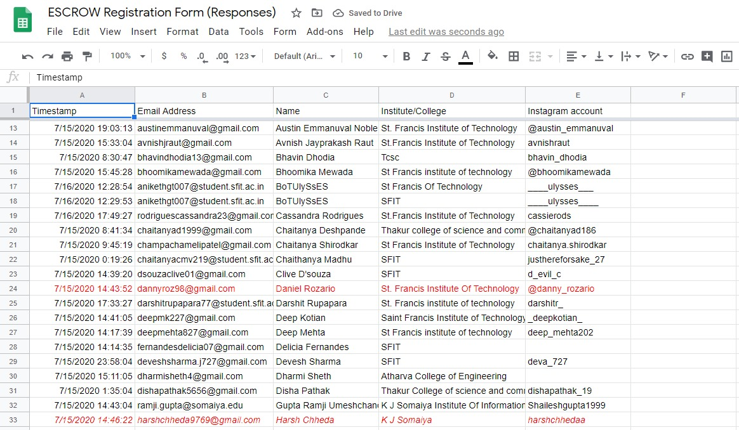

ESCROW had quite a good reach because of the use of social media platforms for promotion as we had more than one hundred registrations. We had fifty seven participants for the first round; out of which 23 participants actually managed to clear the round. We introduced open entries again for round two and had 44 participants. Five contestants were finally qualified in the final round amongst whom Harsh Chheda (solving time 3hrs 40mins) secured the second place and Danny Rozario (solving time 2hrs 28mins) secured the first place.

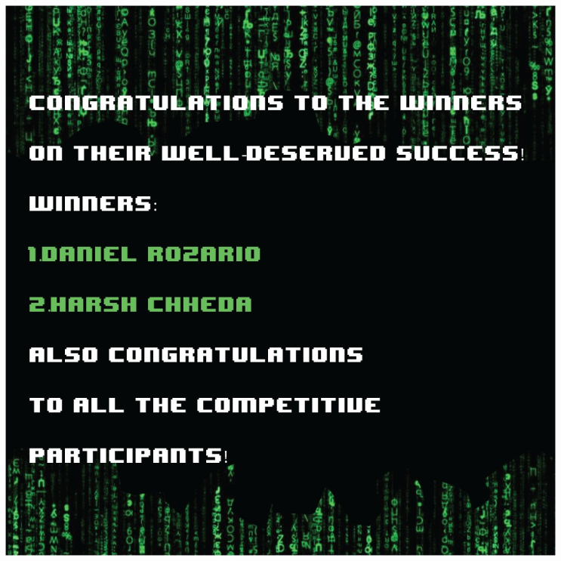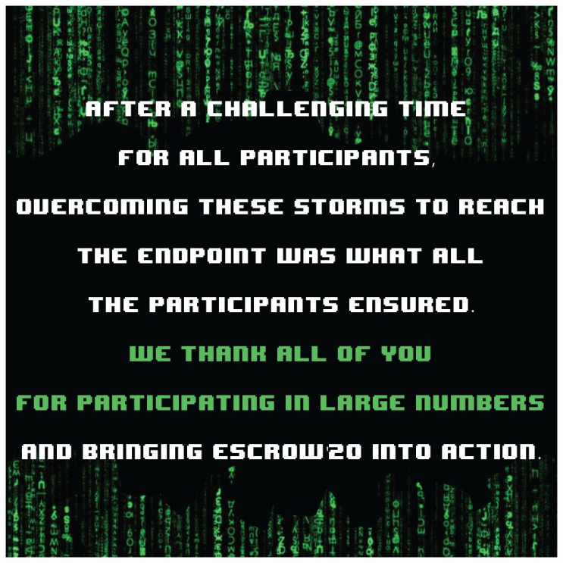

The winners were given a cash prize of rupees 1000 & 700 for First and Second position respectively and acknowledgement on ITSA’ official social media pages.

ESCROW was a great experience for the ITSA team and a successful first step in the academic year.

|  |  |  |
| --- | --- | --- |
| **Mrs. Grinal Tuscano** | **Mrs. Shree Jaswal** | **Dr.Joanne Gomes** |
| **(ITSA Coordinator)** | **(ITSA Coordinator)** | **(HOD-IT)** |